Name : Sundara Moorthy
Reg No : 192324228
Course code : Cloud Computing And Big Data Analysis
Exp No : EXPERIMENT 9
Date : 24/12/2025

EXPERIMENT 9
Title
Creating and Testing Snapshot of a Virtual Machine

Aim
To create a snapshot of a virtual machine and restore it to a previous state.

Procedure
- Start the virtual machine.
- Go to Snapshots → Take Snapshot.
- Name the snapshot.
- Make changes to the VM.
- Restore the VM to the snapshot state.

Output
- VM restored to its previous version.

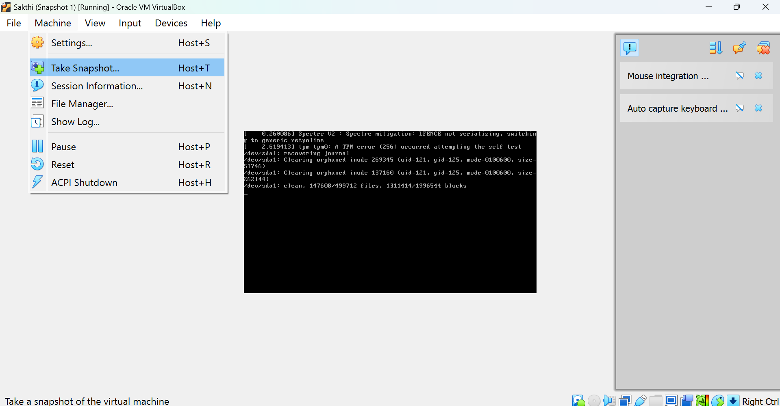

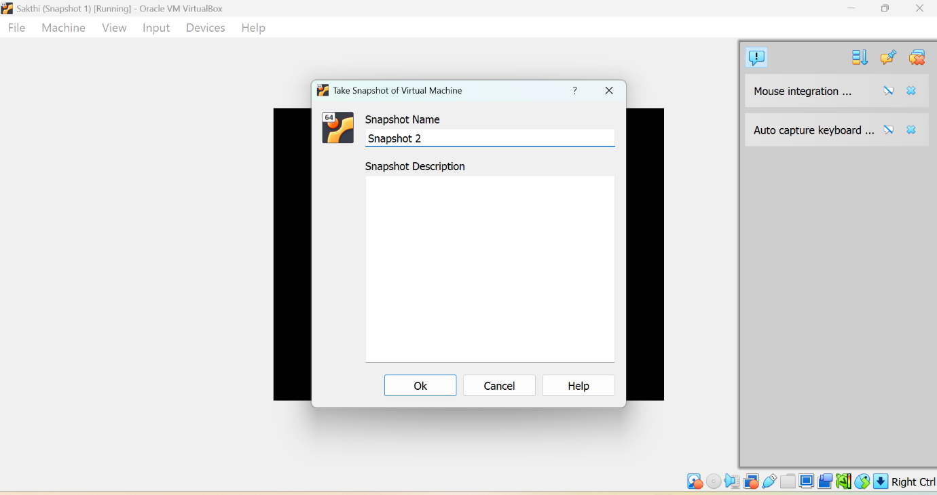

Result
Thus, snapshot creation and restoration of a virtual machine were successfully tested.

